**Biofilms in the continental deep subsurface: implications for planetary habitability**

C. P. Casar1, M. R. Osburn1, T. M. Flynn2, A. L. Masterson1, B. R. Kruger3

1Northwestern University (Evanston, IL), 2Argonne National Laboratory (Argonne, IL), 3Desert Research Institute (Las Vegas, NV)

**Rationale:** If extant extraterrestrial life exists, it likely resides in a subsurface environment. The subsurface offers protection from surficial environmental stressors and lithotrophic energy sources from rocks and fluids. Biofilm formation on mineral surfaces is a common ecological niche in subsurface systems and may therefore be an important survival mechanism. Given the critical role that biofilm formation may play in deep subsurface survival, it is imperative to characterize the distribution, phylogeny, and metabolic strategies of deep biofilm communities to inform the habitability of other planetary bodies. Here we investigate physiological adaptation to life on mineral surfaces of deep fracture-hosted biofilms in an extraterrestrial analog site called the Deep Mine Microbial Observatory (DeMMO). We installed flow-through in situ cultivation experiments using iron, sulfur, and manganese-bearing minerals at three DeMMO sites located at depths of 800, 2000, and 4,850’ (Fig. 1).

We observe:

* Distinct communities attached to mineral surfaces relative to communities suspended in fluids and attached to inert surfaces.
* Pyrolusite appears to be a favorable electron acceptor as predicated by previous thermodynamic models, particularly for two taxa belonging to the Deltaproteobacteria and Nitrospirae. These taxa are known sulfate reducers, and not previously shown to reduce minerals.
* Members of family Geobacteraceae enriched on magnetite and pyrolusite, taxa known to reduce both Fe and Mn.
* Experiments provide insight into lifestyles of candidate phyla: Omnitrophica appears to be planktonic, Latescribacteria forms biofilms.

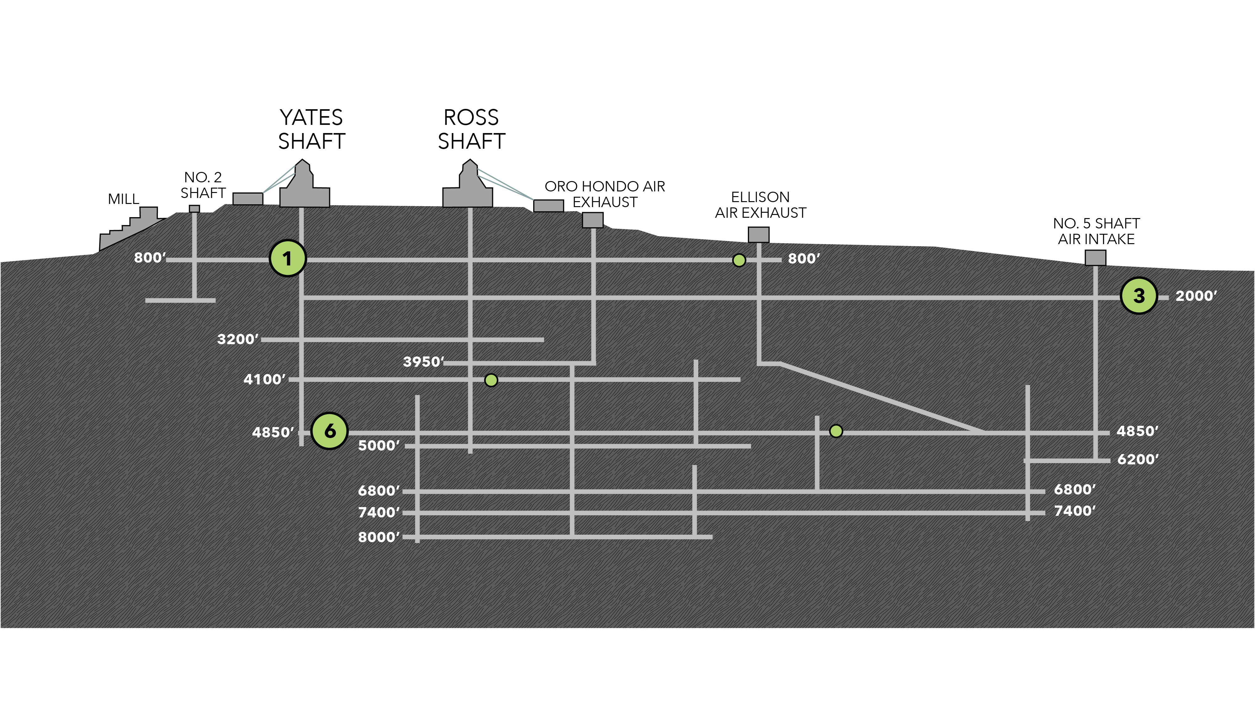

**Fig 1.** The Deep Mine Microbial Observatory (DeMMO) is a network of boreholes (yellow circles) that intersect fluid-filled fractures at the Sanford Underground Research Facility, Lead, South Dakota (former Homestake gold mine). The sites included in this study are located on the 800’, 2000’ and 4850’ levels (DeMMO 1, 3, and 6, respectively).

**Key Findings | 16s rRNA community data**

* Separation of DeMMO1, DeMMO3, and DeMMO6 communities in NMDS space – distinct planktonic and attached assemblages due to variation in fluid chemistry among sites (Fig 2)
  + Broadly, DeMMO6 dominated by Firmicutes, Chloroflexi, and Deltaproteobacteria. DeMMO1 and DeMMO3 dominated by Betaproteobacteria, Nitrospirales, and Omnitrophica
* Separation of fluid communities and biofilm communities in NMDS space (Fig 2)– fluid communities are broadly different from attached communities with some overlapping taxa that are known to carry out free-living and attached lifestyles, i.e. *Gallionella*
* Omnitrophica correlates with fluid communities, Latescibacteria correlates with biofilms (Fig 2). This agrees with other published work suggesting lifestyles for these candidate divisions.
* Geobacteraceae enriched in DeMMO3 experiments with pyrolusite and magnetite (Fig 3) – these are known Fe and Mn reducers. Good that we have signal that makes sense from organism with well-defined metabolism.
* Highest relative abundances of Desulfobulbaceae (family in Deltaproteobacteria) and Thermodesulfovibrionia (class in Nitrospirae) in field experiments with pyrolusite (Fig 3) – suggests MnO2 favorable electron acceptor for these taxa.
* Correlation in NMDS space between pyrolusite, Desulfobulbaceae, and Thermodesulfovibrionia (Fig 2) – plot based on relative abundance data, so this is effectively showing same data in a different way but allows for more data to be compared and for correlations with less abundant taxa to become apparent
* NCBI blast match for most abundant Desulfobulbaceae OTU: 93% *Desulfobulbus propionicus* – this organism was suggested to be capable of elemental S oxidation coupled to MnO2 reduction by Lovley and Phillips 1994 based on culture experiments with an isolate; however, this work was inconclusive. To my knowledge, members of Desulfobulbaceae have not been shown to respire minerals, only soluble substrates. Based on what I heard at ISMET, I believe they have occurred in electrode cultivation experiments using organic carbon as the donor and the electrode as the acceptor. I had a conversation with a PI at ISMET who focuses on Cable Bacteria (members of Desulfobulbaceae) in her lab - in her opinion it is reasonable to hypothesize MnO2 reduction by Desulfobulbaceae based on our experimental results.
* NCBI blast match for most abundant Thermodesulfovibrionia OTU: 86% *Thermodesulfovibrio yellowstoni*. This is a poor match, no close relatives to DeMMO taxa; does not allow for much to be inferred about possible metabolism.
  + Little bit confusing – some websites have Therodesulfovibrio listed under class Nitrospira, whereas SILVA has it listed under class Thermodesulfovibrionia. Since I used SILVA, I’ll go with the latter classification. Thermodesulfovibrio are in order Thermodesulfovirbionales. From Bergey’s manual on genus Thermodesulfovibrio – this genus grows optimally at 65C, vibroid, gram-neg, includes chemoorganotrophs, fermenters, and dissimilatory sulfate reducers. Can use sulfate, thiosulfate, sulfite, and nitrate as e- acceptors.
  + The other order listed on SILVA is magnetobacteriales which includes ca. magnetobacterium (which is magnetotactic).

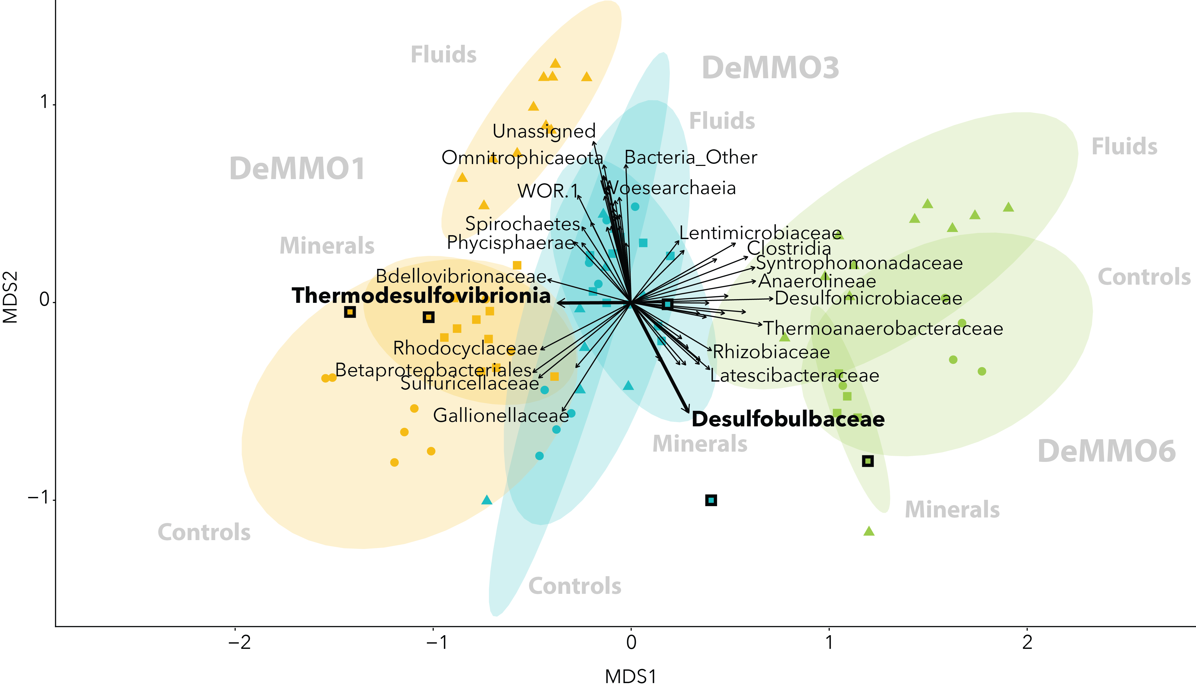

**Fig 2.** NMDS plot of DeMMO1 (orange), DeMMO3 (blue), and DeMMO6 (green) fluid and biofilm communities. Fluid communities, biofilm communities from experiments with minerals, and biofilm communities from experiments with inert controls are represented by triangles, squares, and circles, respectively. Ellipses are 95% confidence ellipses for each community type (fluid, mineral, control) for each site. Fluid communities were sampled approximately bimonthly between December 2015 and April 2018. Vectors represent taxa classified to the family level. Two taxa are shown in bold (Thermodesulfovibrionia and Desulfobulbaceae) that correlate with biofilm communities from field experiments with pyrolusite (outlined boxes).

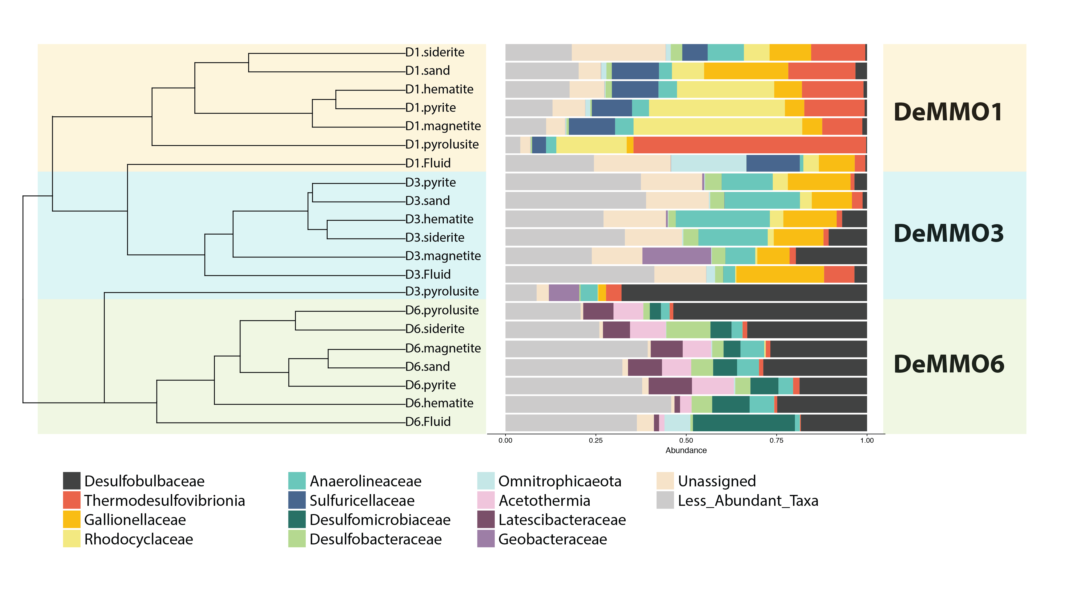

**Fig 3.** Relative abundances of 16s rRNA gene sequences of DNA extracted from fracture fluids and biofilms from DeMMO1, DeMMO3, and DeMMO6 binned at the family level (reference database SILVA132). All bins containing 10% or less of the total reads within a community were combined into ‘Less abundant taxa’.

**Key Findings | Electron Microscopy**

* Highest cell densities estimated for biofilm communities in pyrolusite experiments (Fig 4) – these were based on counts from pyrite, pyrolusite, hematite, and magnetite.
* Mineral Cell density estimates from each site track fluid cell densities from each site (Fig 4). Suggests cell densities of biofilms are in part controlled by fluid densities.
* Diverse cell morphologies including *Gallionella* stalks, curved rods, spiral, cocci, ornate apendages (possibly involved in cell attachment to mineral surface), cell-cell interactions via appendages (conjugation, syntrophy, electron transfer?)
* Bifurcating tube-like structures reminiscent of Leptothrix/Beggiatoa, neither of these taxa detected in 16s data. (Fig 5)
* Wire-like structures coming out of tubes, bifurcating, connecting cells to mineral surface. Possibly involved in electron transfer, possible fungal hyphae (Fig 5)
* Intact EPS and well-preserved cell shapes, makes me confident that deformation due to sample prep was minimal and artifact formation minimized (Fig 5)

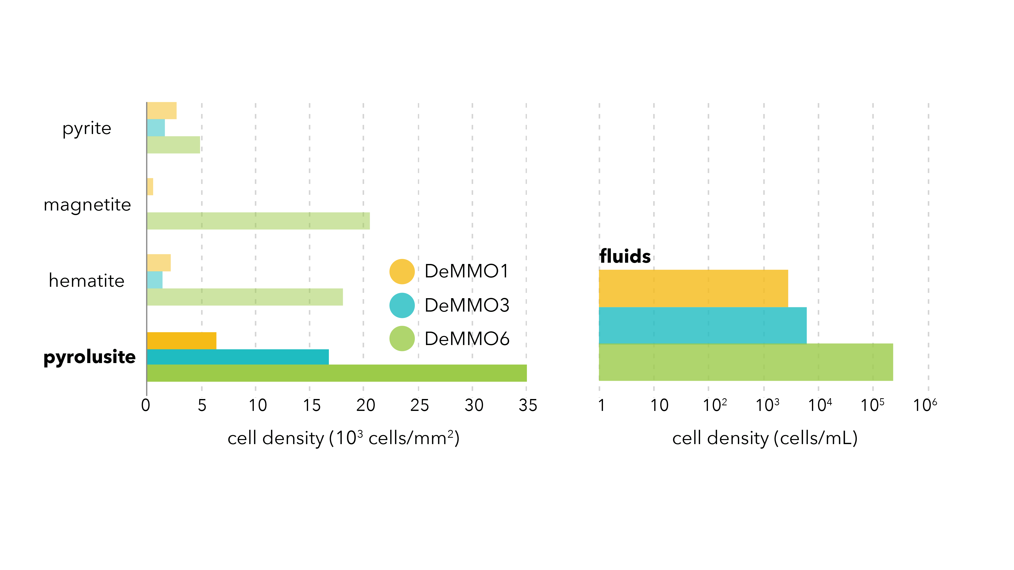

**Figure 4.** Cell densities counted from SEM images (left) and from DeMMO fluids (right).

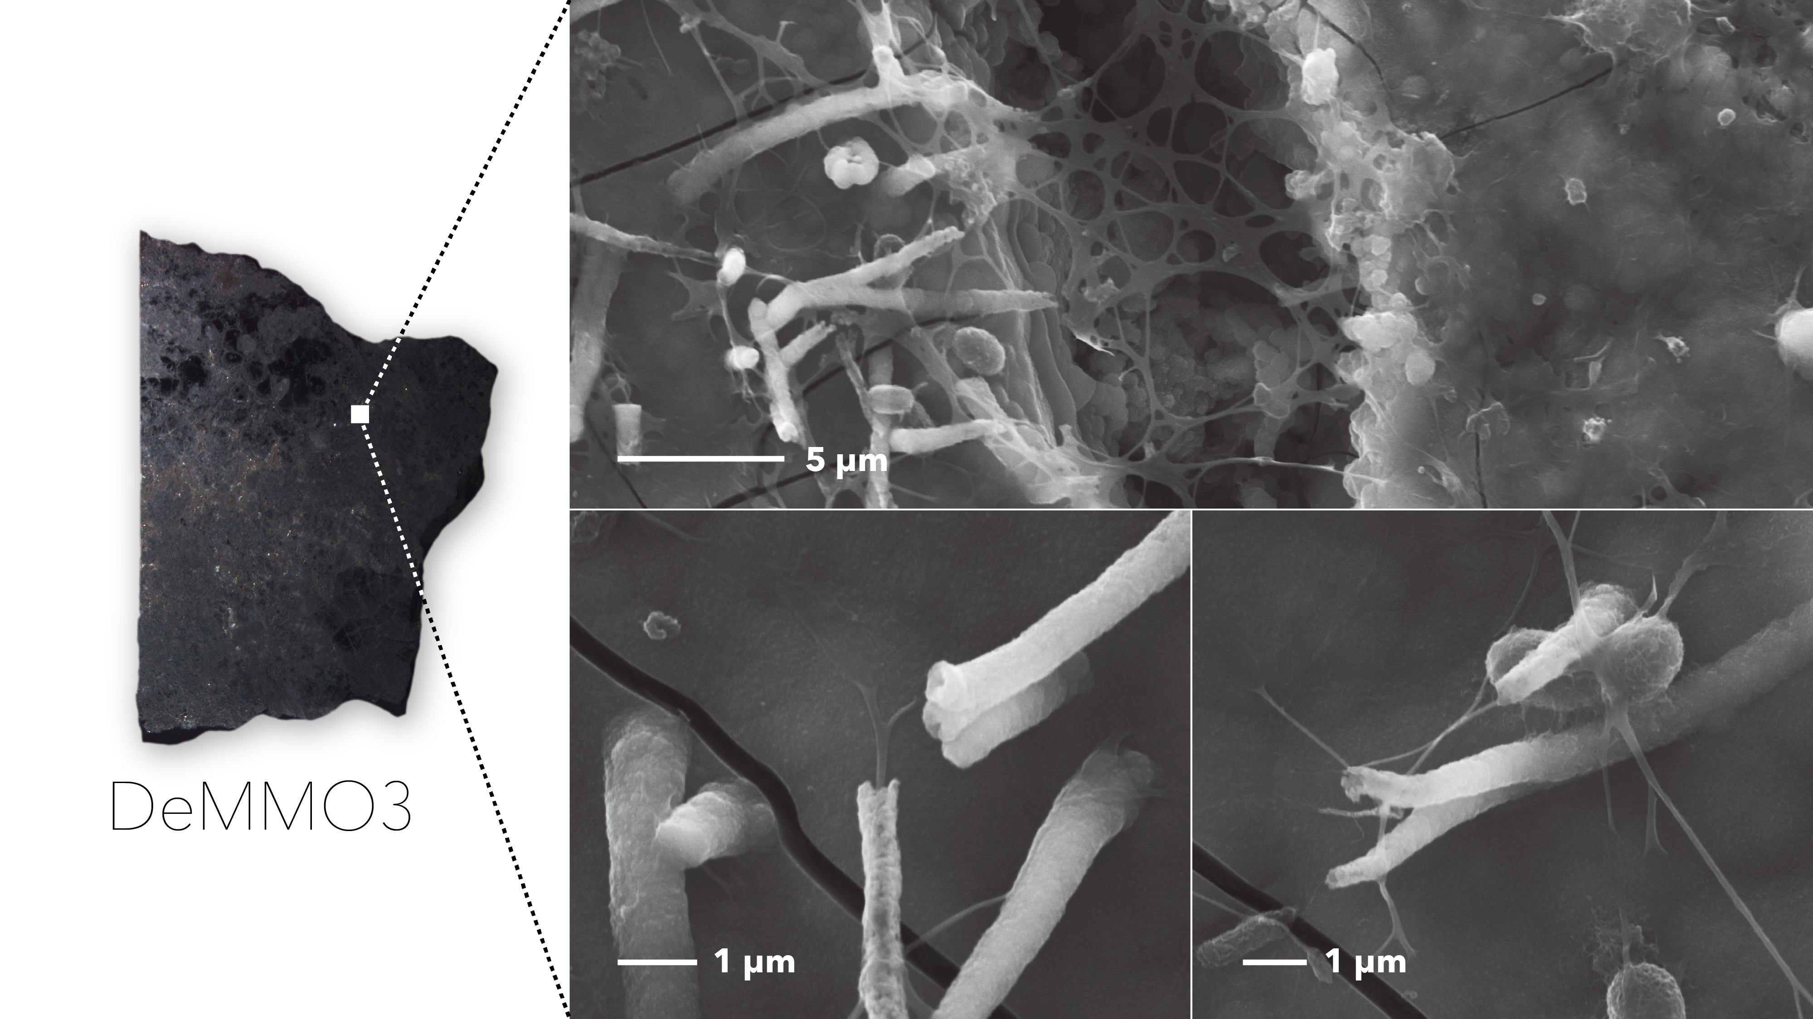

**Figure 5.** SEM images of DeMMO3 pyrolusite showing tube and wire-like structures.

**Data we have**

* 16s rRNA gene sequence data from controls, experiments with minerals and rocks, and experiments with inert controls. Some of these have replicates from different time points. (summarized in fig 6)
* SEM images of mineral and rock chips from most experiments.
  + Missing image of siderite from DeMMO1. There are replicate polished mineral chips from several experiments that could be imaged to probe for reproducibility and beef up cell density estimates. I also included glass slides in each experiment that could be imaged as internal controls, although texture is a strong control on biofilm formation and the glass is much smoother than the minerals. Therefore, glass may not be the most appropriate internal control.
* Cell count data from mineral chips and control glass slides – this data is patchy due to low resolution of some images due to surface charging in SEM.
  + I think it would be worthwhile to try to re-image chips or image replicate chips to get more statistically sound density estimates.
* Cell densities from fluids.
  + This may require a re-count to check for contamination.
* Geochemistry of fluids from May 2016 to November 2017.
  + Missing data for April 2018.
* DeMMO host XRF bulk rock chemistry from rocks collected near DeMMO1, DeMMO2, DeMMO3, and Yates member.
* Thermodynamic models of metabolisms with magnetite and pyrolusite at DeMMO1 and DeMMO6 from Maggie’s 2014 paper.
  + I think it would be useful to have models for the rest of the minerals in the field experiments (pyrite, siderite, hematite, possibly muscovite and gypsum but these were only installed at DeMMO1 and DeMMO3), as well as models for missing site DeMMO3. I don’t think I can figure this out on my own in a reasonable amount of time, but maybe it’s possible to collaborate with Doug LaRowe or someone who’s more familiar with thermo modelling?

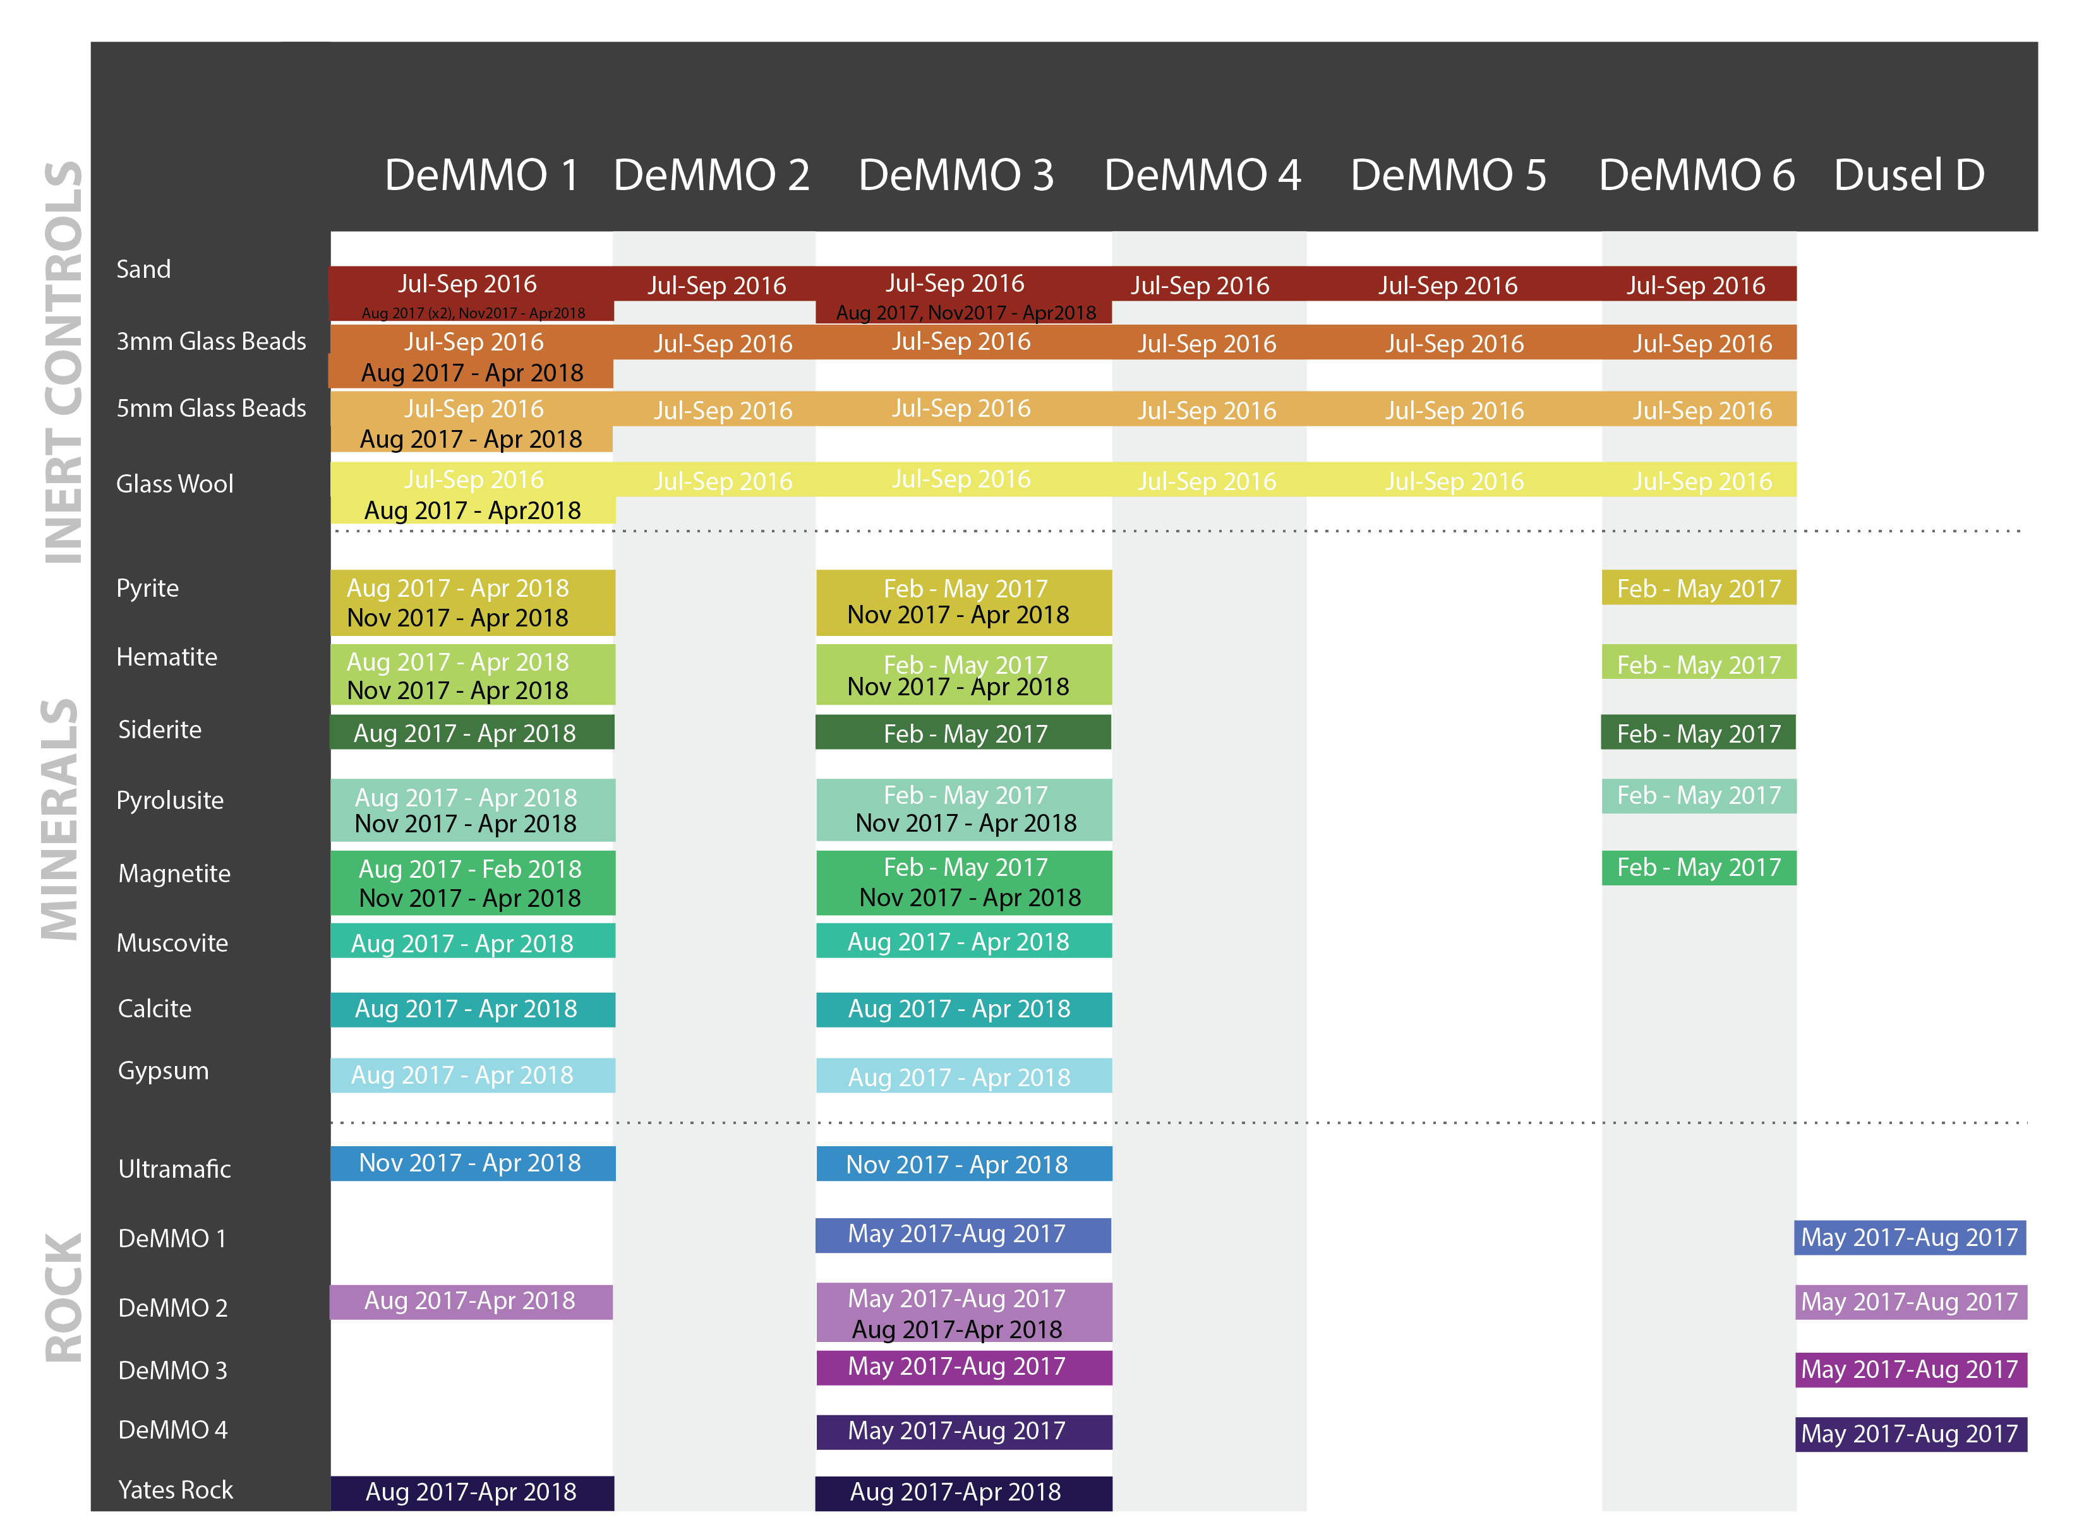

**Figure 6.** Overview of in situ cultivation experiments carried out to completion at DemMO to date.